**INF 1511 – Revision notes – Chapter 1**

1. **Introduction**

Python is a powerful high-level, dynamic object-oriented programming that is implemented in C, and relies on the extensive portable C libraries.

Python is an interpreted programming language, which means that it can be executed by the computer without compiling. Compiling is the conversion of a programing language into machine instructions that can then be executed by the computer.

C is a general-purpose, computer programming language, supporting structured programming.

The implementation of Python studied in the course is called CPython, or Classic Python (often just called Python) other implementations are Jthon and IronPython.

1. **Using Python**

**Python can be used on through the command line**

The command line is used to execute one line of Python code at a time. Note that the commands executed this way cannot be saved.

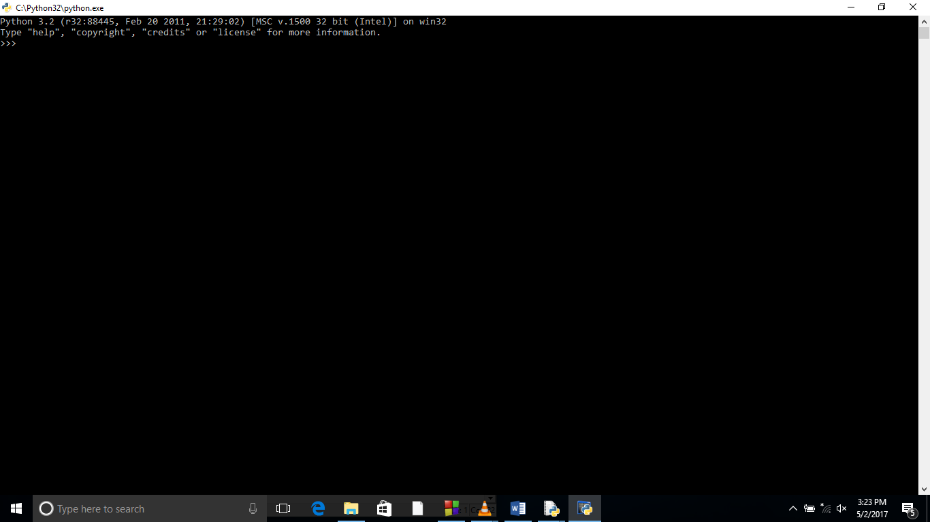

To ensure that Python can be executed from any folder on a computer, the Path variable in the Environmental Variables must be updated with the path of the Python installation.

**Or the IDLE IDE**

The IDLE enables the programmer to save Python code in a file and execute all the code at once. One can edit, debug and preview code in the IDLE.

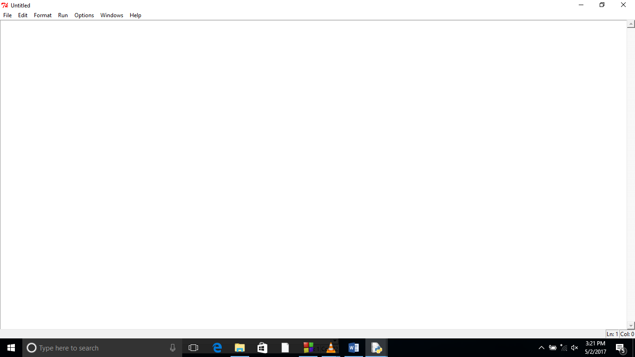

1. **Basic Elements in a Program**

Programs consist of the following basic elements, a collection of literals, variables, and keywords.

**Literals**

A *literal* is a number or string that appears directly in a program, e.g.

10 # Integer literal

10.50 # Floating-point literal

'Hello' # String literal

"World!" # String literal

'''Hello World!

It might rain today # Triple-quoted string literal

Tomorrow is Sunday'''

In Python, you can use both single and double quotes to represent strings. The strings that run over multiple lines are represented by triple quotes.

**Variables**

Variables are used for storing data in a program. E.g.

l = 10

Length = 10

k= "Hello World!"

a = True # Boolean variable

b = [2, 9, 4] # List variable

c = ('apple', 'mango', 'banana') # tuple variable

A tuple in python language refers to an ordered, immutable (non- changeable) set of values of any data type.

**Keywords**

Python has 30 keywords: ensure you’re familiar with the ones used in the textbook examples and assignments.

**Comments**

These are preceded by #, they are ignored by the interpreter and are used to make the code more readable.

**Continuation Lines**

Two types of lines in Python are called physical (e.g. the 7 lines in the code below.

A logical line is a combination of several physical lines, e.g. line 2, 3 and 4.

1. print (10)
2. print ('Hello World! \
3. It might rain today. \
4. Tomorrow is Sunday.')
5. print ('''Hello World!
6. It might rain today.
7. Tomorrow is Sunday.''')

Check page 33 of the textbook for the ways in which physical lines can be joined into one logical line.

**Printing**

print (["message"][variable list])

The print statement above prints the string in message and a list of variables in the optional variable list.